Google Guru 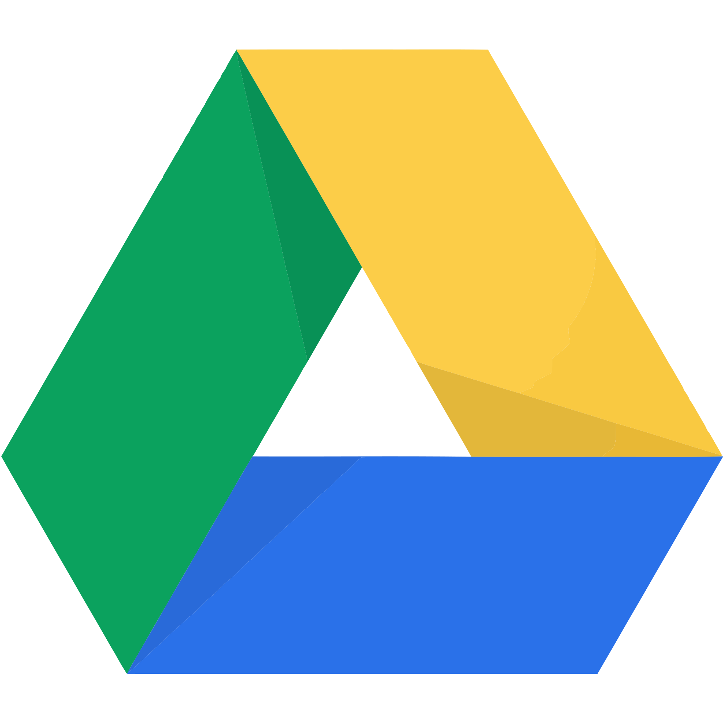

Let’s get Googley!
Complete two tic-tac toes and the black out for
Google prizes and the honor to be called
Google Guru!

Passion Presentation with Google Slides | Google Forms Survey | Create a Hyperdoc
Personalize your Digital Portfolio | Share your creations on this Padlet. | Create a Shapeogram using Google Drawings
Organize your Drive | Get Googley | AR Spreadsheet  