Meet Microsoft Teams
Get started with the digital hub for teaching and learning in Office 365 for Education
Guide for Educators
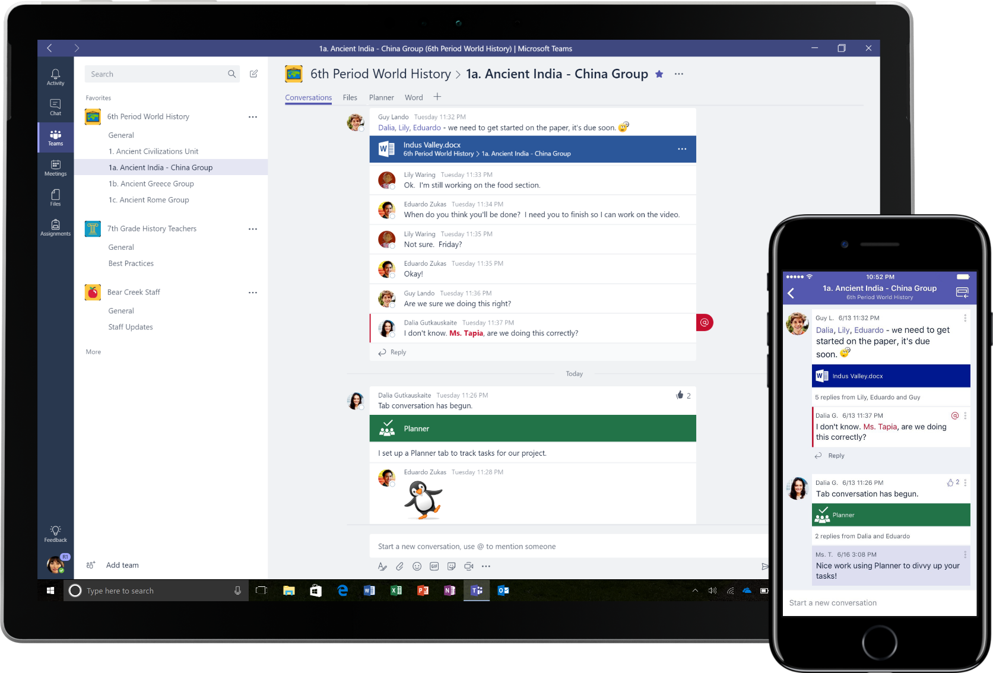

Easily manage your class workflow while engaging the voice within every student
- PRIMARY SCHOOL TEACHER

“Microsoft Teams has given every student – even the quietest ones – a voice in my class.”
Microsoft Teams is a digital hub that brings conversations, meetings, files and apps together in a single experience in Office 365 for Education. Using Teams, teachers can move quickly and easily from conversations to content creation with context, continuity, and transparency. Teams addresses the unique needs of different groups and enables them to work together easily and get things done:
- Manage projects, tasks, and content using the applications that you use every day—all available in a single, custom workspace
- Stay in the know with real-time information and updates shared in persistent team conversations, private chats (these can be moderated, if needed), team meetings, and other channels
- Support rich collaboration and seamless experiences with integrated apps from Office 365 like Word, Excel, PowerPoint, and OneNote Class Notebook, and education partners like busuu, Canvas, Flipgrid, and Kahoot!
Office 365 for Education now includes Teams. This means that Teams is free for all faculty, staff, and students through Office 365 for Education!
The table below describes a few examples of ways teachers can work together in Teams, to help support innovative teaching methods and best practices in collaborative classrooms and schools.
Hinton, M. (2017, March). Study Links After-School Programs to Improved STEM Knowledge. Education Week. Retrieved from http://blogs.edweek.org/edweek/time_and_learning/2017/03/new_study_examines_link_between_after-school_programs_stem_knowledge.html?cmp=eml-enl-eu-news3
Learn more about the new experiences in Teams designed for teachers, students, and staff!
Scenario | Description
Engaging classroom experiences | Save time and easily organize classroom discussions, manage assignments, and collaborate with students to create personalized learning environments and address your students’ unique learning and development needs.
Lesson planning | Developing lesson plans for different subjects and grade levels requires effective communication and collaboration among teachers across the school or district.
Professional learning communities | Collaborate in professional learning communities (PLCs) and share best practices to help shape professional development opportunities and support to your peers.
After-school programs | A recent study found that after-school programs overwhelmingly improve students’ STEM career knowledge (80%), promote a more positive attitude about STEM (78%), and increase perseverance and critical thinking skills (72%)¹. Teachers can work together to constantly create exciting and stimulating activities to encourage students to participate in these important, voluntary programs.

Understanding Teams
You can create teams for different class periods, projects, and activities as needed, and invite others in the school or district to join as team members. Teams can also be created based on existing Office 365 Groups, and any changes made to the Office 365 Groups will automatically be synced in Teams. This simplifies the process of inviting and managing team members, and saves group files in Teams.
For example, individual classes can be further organized into channels that contain tabs for conversations, files, notes, and more. Channels can be created based on the class’s different needs, for example, by unit, subject, or by project-based group. Tabs enable the class to upload, review, and edit files, notes, and customized content (such as documents, spreadsheets, presentations, videos, external links, other applications, and more). This content is then easily accessible to everyone in the class.
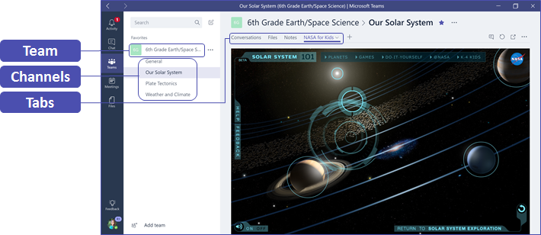
Setting up Teams on your mobile device is easy and will ensure you can conveniently stay connected with your class from anywhere, at any time, and on any device. You can download Teams from the Windows Store (Windows Mobile), App Store (Apple iOS) or Google Play (Android).

Introduce Teams to your class
Begin with a kickoff meeting to set expectations, provide guidance, and demonstrate the basics of Teams. Ask your class to use Teams as their primary communication and collaboration tool for your team-based activities.

Customize Teams for your unique scenario
Successful teams need simple and intuitive tools to enable fast and effective communication and collaboration. Whether you’re preparing lesson plans, creating a personalized learning environment, developing an after-school program, or managing any other team-based activity or project, Teams can help you get organized for success. In the following steps, we’ll show you how to get started and customize Teams for your class scenario.

Create your team and invite team members
- To launch Teams, go to the app launcher – the “waffle” – in the upper left corner of Office 365 for Education and click the Teams tile to open the online app, or download it to your desktop.  Note: If you’re having trouble accessing Teams, contact your IT Admin to make sure you have the right license. | 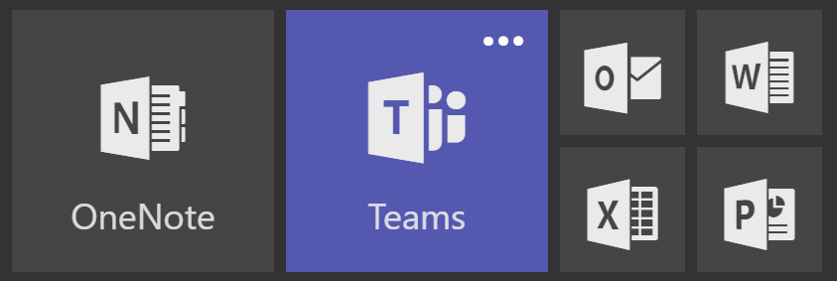
- Click the button at the bottom of the channel list in Teams, then click the button on the Create a team and then select Class.  Note: If your school uses School Data Sync, your classes will automatically be created for your with student rosters connected to your school’s information system, so you don’t have to worry about this step. | 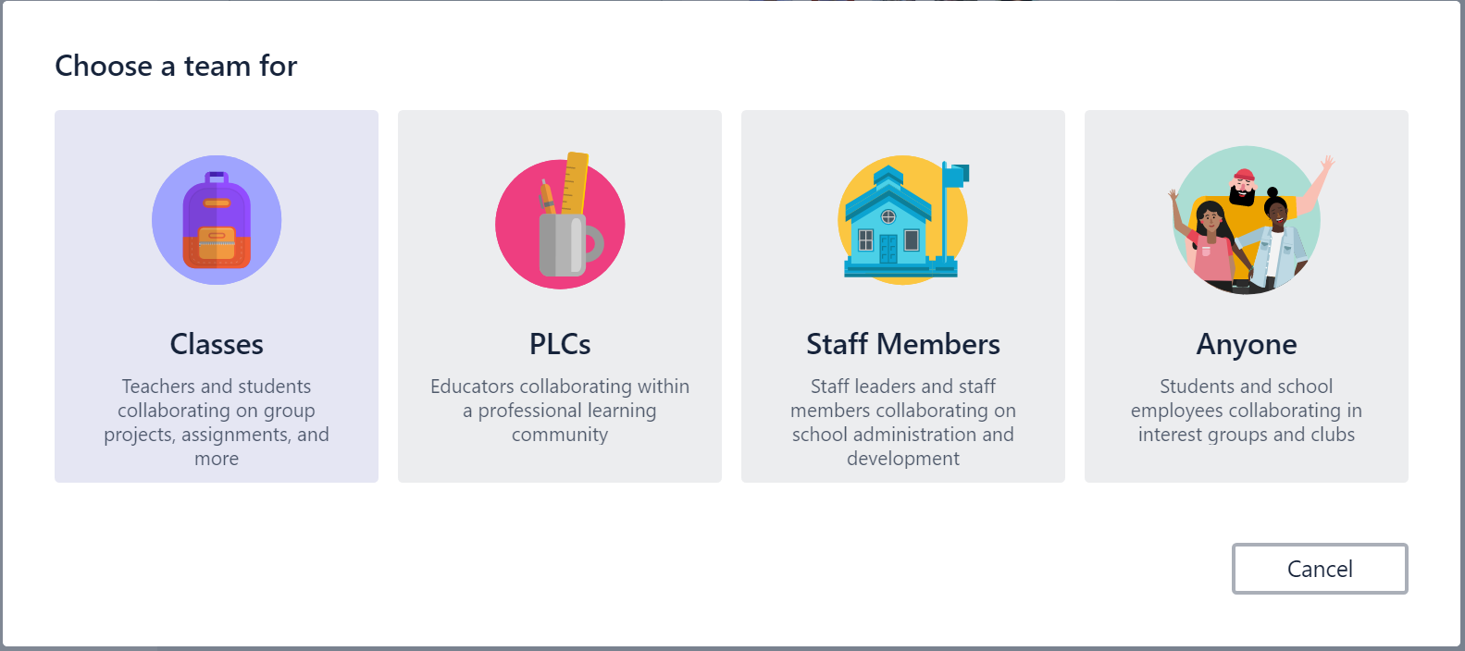
- In the Create your team window, name your class and write a brief description that explains the purpose of the class, then click the button.  Note: Leave the Privacy option set to Private—Only team owners can add members (you can change this setting later if needed).  Before you train your class, go ahead and customize the setup of Teams. Begin by creating your class, setting up a few channels, and adding a few tabs. Then seed a few tabs with some relevant, engaging, and helpful content. | 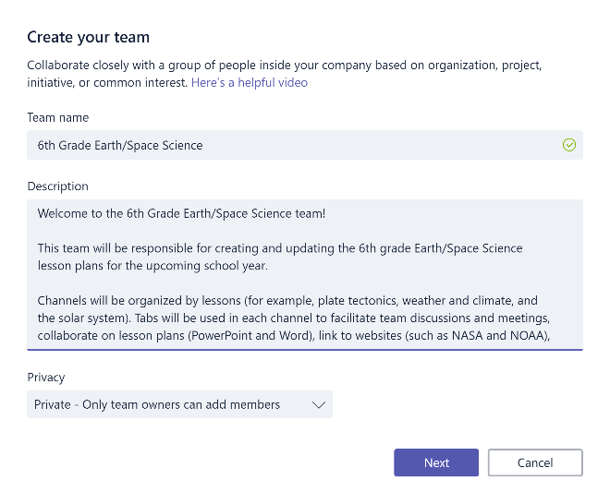
- You can easily add people, groups, and distribution lists from your school or district. As you begin typing names, a dropdown list of people in your email directory matching your spelling will appear. Click the button to add team members, or click the button to add team members later if you want to set up your content first (recommended). | 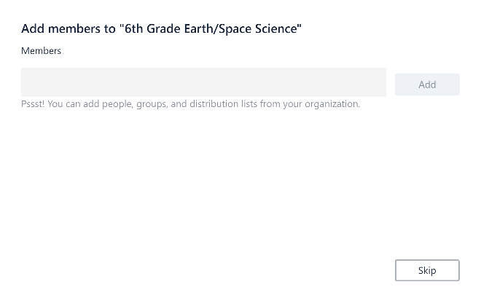

Create a few key channels and some tabs with great content
- When you create a new class, a General channel is automatically added to the class. You can create additional channels to keep your class organized. By default, anyone on the team can access these channels.  Post Teams training tips and announcements to the General channel for easy reference. This will be a convenient place for the entire class to get help and guidance, but especially useful for new members joining Teams. | 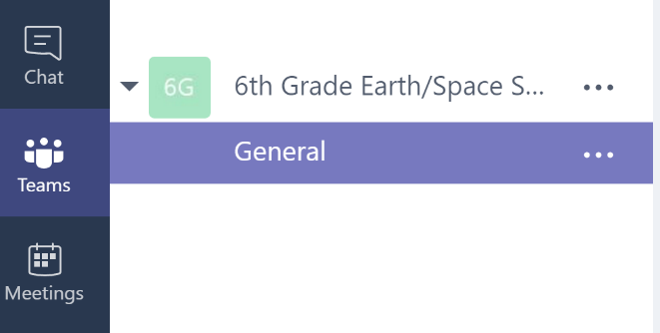
- To create additional channels, select the ellipses next to your team name in the channel list and select Add Channel from the dropdown menu. | 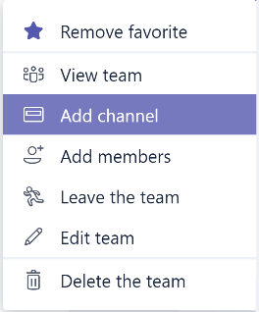
- In the dialog box, name your channel and write a brief description that explains the purpose of the channel, then click the button.  Once you’ve created a few channels, you can seed them with some actual content so that your class doesn’t see a blank page the first time they log in. For example, you might start a new conversation by posting a few questions in each channel to get a few discussions started and @mention specific class members to pull them into the conversation. | 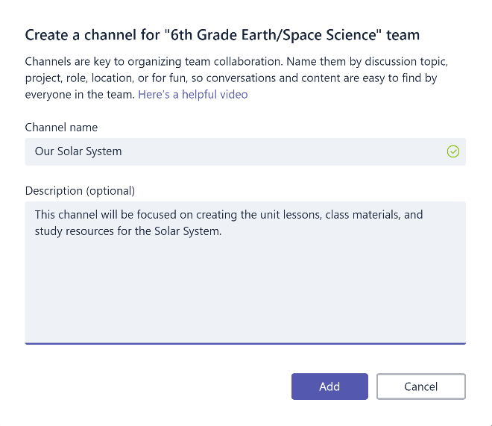
- Within individual channels, you can create tabs for different content and applications. Several default tabs are created within each channel, including Conversations, Files, Class Notebooks, and Assignments. To create a new tab, click the + to the right of the default tabs, then select an app or file for the tab (such as Word or Planner), name it, and click the button.  Note: The setup steps for some applications and services may differ slightly from the instructions provided here. | 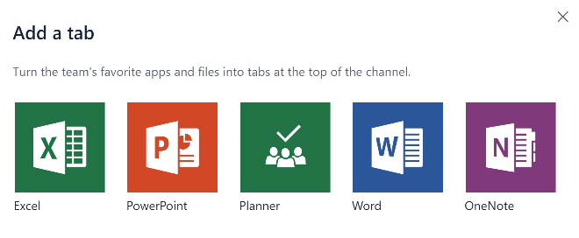
- To create a new tab that links directly to a specific file (such as a lesson plan or outline or an interactive class presentation), click the + to the right of the default tabs, then select the app for the file type (such as a Word document, Excel spreadsheet, or PowerPoint presentation), browse to the file name under Files, name the tab, and click the button.  You can pin an existing OneNote Class Notebook from a SharePoint site or other website ( ) directly to your channel as a tab for easy team access. | 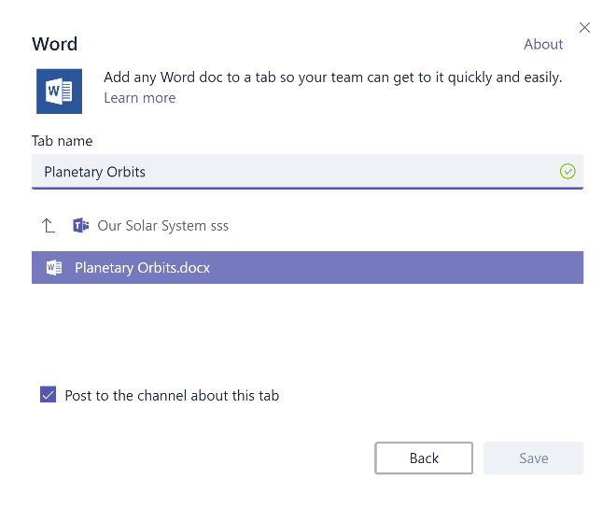

Move email conversations to Teams
- You can send emails to a channel within Teams to keep all your class communications organized and accessible in one place. To create an email address for a channel, click the ellipsis ( ) to the right of the channel, select Get email address in the dropdown menu, then click the button and save the email address to your contacts list or email address book.  Forward emails into a channel to continue discussions in Teams. | 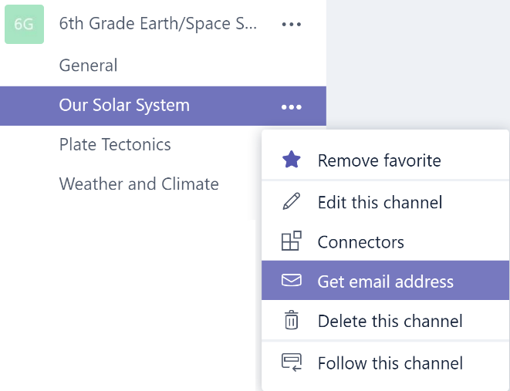
- You can click the advanced settings link in the Get email address window to limit who can send emails to the team (for example anyone, only team members, or only emails sent from specified domains).  Limiting who can send emails to a channel will help reduce the likelihood of receiving spam or phishing emails in Teams. | 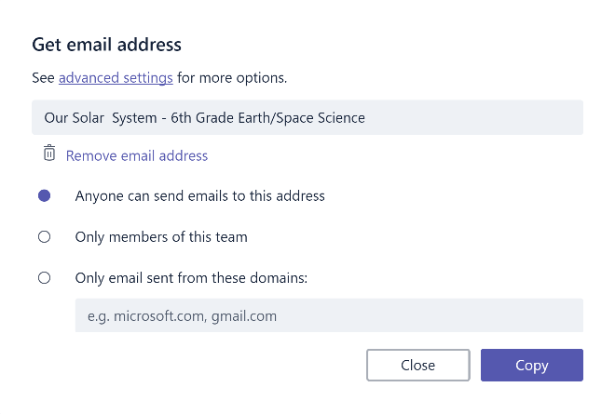
- You can customize your email notification settings for different events (such as personal @mentions or replies to conversations you start) by clicking on your profile picture in the lower left corner of Teams, then selecting Notifications from the dropdown menu. | 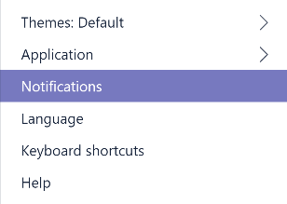

Create class assignments
- To create assignments in Teams, click Assignments tab in your class Tab then click the New Assignment button in the top right corner. | 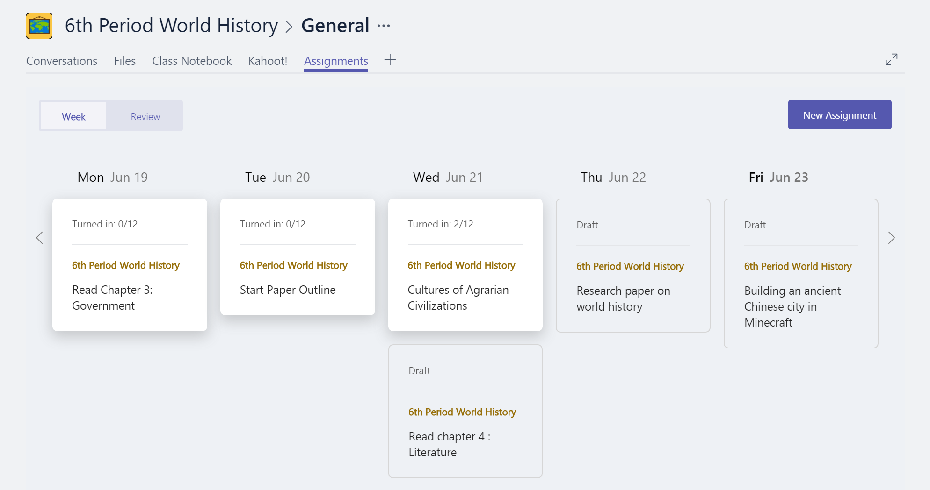
- In the New assign window, add your assignment details and Attach reference materials for your students. You can schedule a Due date and Time due, and even decide whether your will allow Late turn-ins. When you’re done, click on the Assign button.  You can save the assignment as a Draft if you’re not ready to distribute it yet. Just come back to your Assignments tab later to Assign. | 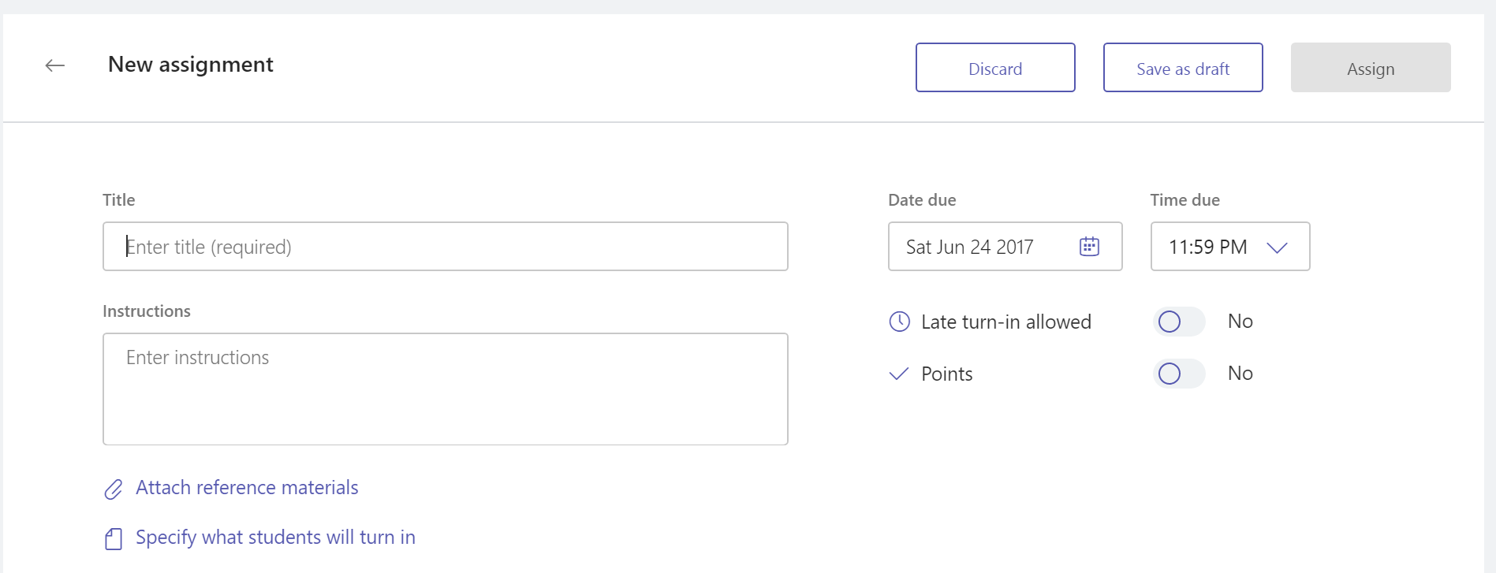
- To Review and Grade students’ work, head back to the Assignments tab in your class. Select Review to see all the Assignments your students have turned in.  You can provide feedback and notes down the list or select an individual student’s submission to see their Assignment. You can also navigate to other students quickly and easily right from that view. | 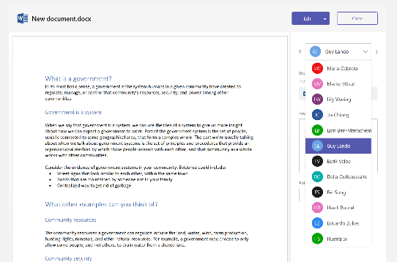  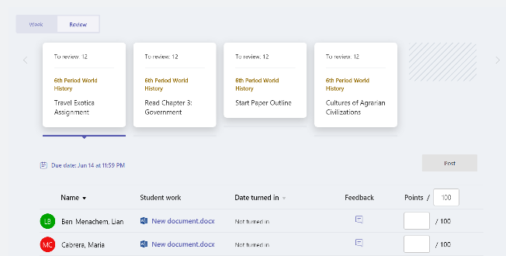

Reviewing what you’ve learned about Teams
- Teams is digital hub for teaching and learning that is fully integrated with Office 365 for Education, so team members can easily communicate and collaborate using familiar Office 365 applications like Word, Excel, OneNote Class Notebook, and PowerPoint. For Office 365 for Education subscribers, Teams is free, so you can start right away!
- You can organize your team using custom channels and tabs that you create to meet your collaboration requirements. Tabs can link directly to files or other content, or to Office 365 applications such as Planner and PowerBI, or apps from education partners like busuu, Canvas, Flipgrid, and Kahoot!
- Use your move emails to Teams to keep all of your class conversations in one place.
- Create Assignments to easily manage your end-to-end class workflow in your class – move from creation and distribution to grading and feedback in no time.
- You can read more about the new experiences in Teams in Office 365 for Education here on the Education blog.

